**Energy**

**Supply**

**Northern Ireland**

**Housing Statistics**

**2017-18**

**Originally Published 04/12/2018**

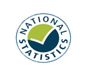

The Northern Ireland Housing Statistics is an annual compendium of statistics which provides information on a range of areas relating to housing. The report is divided into sections covering: Supply; Energy; Social Renting Demand; Private Renting Demand; Owner Occupier Demand and Household Characteristics.

**Annual Publication**



**Key Points**

**Social Renting Demand**

**Private Renting Demand**

**Owner Occupier Demand**

**Household Characteristics**



**Total**

**Housing Stock**

**790,328**

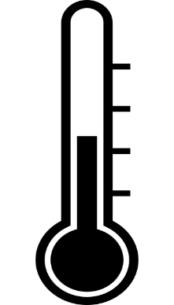

* The Affordable Warmth Scheme has improved 4,148 homes in 2017/18
* Between 2012-13 and 2017-18 38,537 Boiler Replacement Grants were approved, amounting to £26.1 million
* On 20 March 2018 there were 36,198 applicants on the Social Housing Waiting List.
* Of these applicants, 24,148 were in ‘housing stress’
* In 2017-18 11,877 households were accepted as statutorily homeless

**Private Sector**

**£98**

**Estimated Median Weekly Rent 2016/17**

**Social Sector**

**£77**



* In Quarter 3 of 2018, the House Price Index (HPI) stands at 121.7.
* HPI Base Period: Quarter 1 2015 = 100.
* The standardised house price for this Quarter is £135,060
* This is a 4.8% increase since the same Quarter last year



**£**

**£691**

**Average Weekly Household Income 2016-17**



**Revised: 20/02/2019**

**Contents**

**Introduction**

**Contact**

If you have any queries or comments relating to this issues of the Housing Statistics publication, please contact ASU via:

**Telephone:** (028) 9082 9093

**E-mail:** [asu@communities-ni.gov.uk](mailto:asu@communities-ni.gov.uk)

**Housing Team: James Sampson, Lauren Kinnear, Katie Fulton, Andrew Shiels**

ISBN 978-1-904105-98-5

ISSN 0144 4433

© Crown Copyright 2018

This annual compendium of statistics contains information on a range of areas relating to housing. The report is divided into sections covering: Supply; Energy; Social Renting Demand; Private Renting Demand; Owner Occupier Demand and Household Characteristics. In this summary document you will find quick and concise coverage of each of these topics. More in depth statistics and information on methodology can be found in the accompanying tables and appendix documents at:

<https://www.communities-ni.gov.uk/publications/northern-ireland-housing-statistics-2017-18>

**The Northern Ireland Housing Statistics 2017-18 is the second edition of this series to reflect a restructuring of format. These changes have been introduced with the intention of creating a simplified and visually appealing format that will help explain the statistics and aid understanding. We welcome user feedback, so would like to encourage your participation in our user engagement survey, and thank you in advance:**

<http://www.smartsurvey.co.uk/s/HOUSING_STATISTICS_USER_ENGAGEMENT/>

*The United Kingdom Statistics Authority has designated these statistics as National Statistics*.

National Statistics status means that official statistics meet the highest standards of trustworthiness, quality and public value. All official statistics should comply with all aspects of the Code of Practice for Official Statistics. They are awarded National Statistics status following an assessment by the Authority’s regulatory arm. The Authority considers whether the statistics meet the highest standards of Code compliance, including the value they add to public decisions and debate.

It is a producer’s responsibility to maintain compliance with the standards expected of National Statistics. If we become concerned about whether these statistics are still meeting the appropriate standards, we will discuss any concerns with the Authority promptly. National Statistics status can be removed at any point when the highest standards are not maintained, and reinstated when standards are restored.

The following symbols are used throughout the publication:

.. Not Available

- None

** Negligible

* Suppressed

(P) Provisional

(R) Revised

N/A Not Applicable

1

**Supply**

**2**

**Energy**

**4**

**Social Renting Demand**

**5**

**Private Renting Demand**

**7**

**Owner Occupied Demand**

**8**

**Household Characteristics**

**10**

*This publication was revised due to the identification of missing cases within Social Housing Waiting List Quarter 4 2017-18 extract.  It should be noted that the statistics represent a snapshot of the Waiting List and Housing Stress data at 20 March 2018. This affects table 3.5 and 3.6 as well as the corresponding text on the front cover and page 5 of this document.*

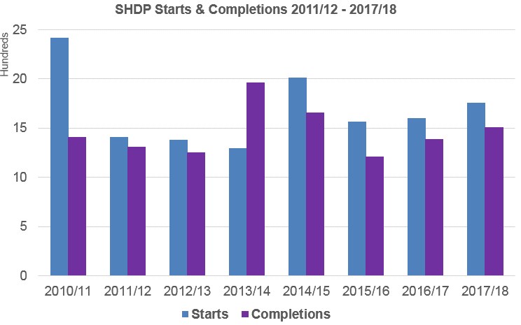

This section provides a wide range of information relating to housing supply. Detailed data and methodology notes on housing stock, tenure, new dwelling starts and completions, volume of construction, and planning applications and decisions can be found in the [accompanying tables](https://www.communities-ni.gov.uk/system/files/publications/communities/ni-housing-stats-17-18-tables1.XLSX) and the [section 1 appendix](https://www.communities-ni.gov.uk/system/files/publications/communities/ni-housing-stats-17-18-appendix1.DOCX).

**Section One - Supply**

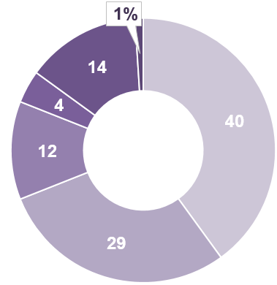

* In 2017/18 dwellings that were owned outright and dwellings that were owned with a mortgage accounted for 69% of households sampled (40% and 29% respectively).
* In the same period 14% of households sampled rented privately and 4% rented from Housing Associations.
* NIHE rented properties made up 12% of households sampled.



**Household Tenure 2017-18**

**Social Housing Development**

**Programme 2017-18\***

* The Social Housing Development Programme (SHDP) provides social housing in Northern Ireland. It is managed by the Housing Executive’s Development Programme Group (DPG) which provides grant funding to housing associations so that they can build or acquire new social housing.
* Since 2010/11 11,701 social houses have been completed through this scheme. Of these 96% were self-contained and 4% were shared.
* In 2017/18 there were 1,759 SHDP starts. This is a 10% increase on 2016/17 (1,604).
* In the same period there were 1,507 SHDP completions. This is a 9% increase on 2016/17 (1,387).

2

**Total Stock per 1,000 population**

**2017-18**

**Average Household Size**

**2016-17: 2.5**



**Key Housing Supply Figures**



**Total**

**Housing Stock**

**790,328**

**April 2018**

**419**

This is a 1% increase from 2017 (783,272)

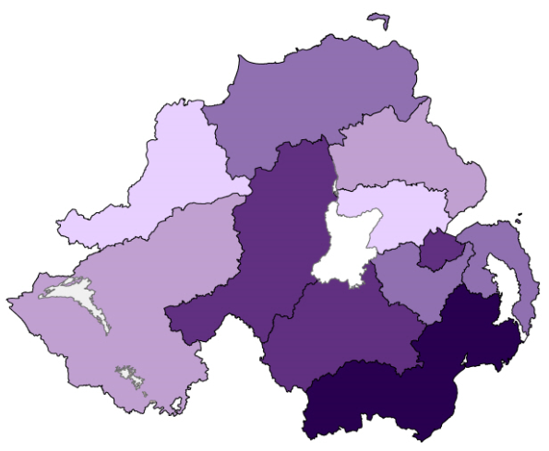

32

**Section One - Supply**

**Building Control Starts & Completions 2017-18\***



**7,517**

**New Dwelling Starts**

**3% decrease on 2016-17**

**6,731 new dwelling starts**

**5,886**

**new dwelling completions**

**1,214**

**new dwelling completions**

**New Dwelling Completions**

**7,100**

***Social***

***Sector***

**786 new dwelling starts**

***Private***

***Sector***

**Residential Planning Decisions Granted 2017-18**

* Of the 7,382 decisions made in 2017-18, 94% were granted (6,947).
* The majority of residential planning decisions granted related to rural Urban Extensions and Alterations (24%) and Rural New Single Dwellings (25%).
* Newry, Mourne and Down, and Mid Ulster Local Government Districts received the greatest number of residential planning applications during 2017-18 (1,043 and 918 respectively).

**Map based on Planning DFI data and developed by Analytical Services Unit, DfC. © Crown Copyright and database rights MOU209**

* Please note that this publication reports on two different measures of social housing – Building Control and SHDP. These figures often differ from each other, but this is not due to error. The same social housing units are recorded by both data providers, the difference lies in when they are recorded. For more information see Appendix – Section One.

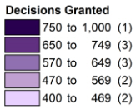

**10% increase on 2016-17**

**Central Heating by Fuel Type, 2016**

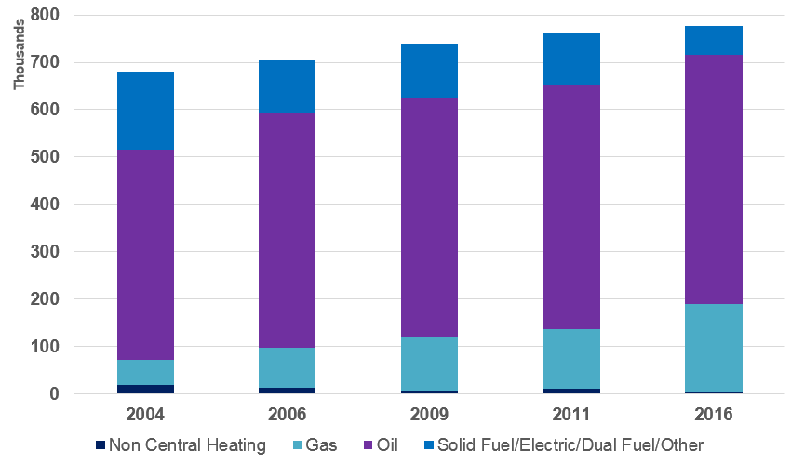

* Information on central heating is taken from the House Condition Survey (HCS), the most recent of which is the 2016 edition.
* The 2016 HCS defines central heating as a heating system with a distribution system sufficient to provide heat in at least two rooms.
* The percentage of homes with central heating has risen from 95% in 2001 to over 99% in 2016.
* Gas has seen the largest increase in installations in this time frame, whilst solid fuel, electric and dual system heating systems have decreased.
* In 2016, oil central heating accounted for 67% of heating systems. This was followed by gas at 24%.

**Boiler Replacement Scheme**

**2017-18**

* The Boiler Replacement Scheme is a DfC scheme, administered by the Housing Executive.
* The scheme is for Owner Occupiers whose gross annual income is less than £40,000, and is to help with the cost of replacing boilers over 15 years old.
* Between 2012-13 and 2017-18, 38,537 grants were approved amounting to £26.1 million. This equates to an average of £678 per household. Of these, 32,100 replacements have been completed.

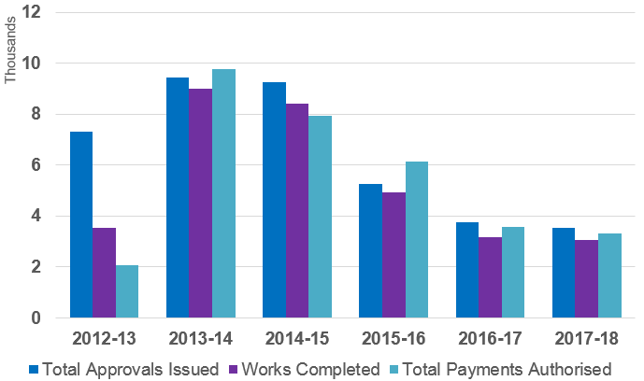

42

**Section Two - Energy**

This section provides information relating to domestic energy. Detailed data and methodology notes on household fuel type, energy efficiency, Warm Homes Scheme and Boiler Replacement Scheme can be found in the [accompanying tables](https://www.communities-ni.gov.uk/system/files/publications/communities/ni-housing-stats-17-18-tables2.XLS) and the [section 2 appendix](https://www.communities-ni.gov.uk/system/files/publications/communities/ni-housing-stats-17-18-appendix2.DOCX).

**Affordable Warmth Scheme**

**2017-18**

The Affordable Warmth Scheme was introduced in September 2014 to replace the Warm Homes Scheme. The scheme is targeted at fuel poor households in the private sector.

There were a total of 4,312 approvals issued in 2017/18 and a total of 4,148 homes were improved in 2017/18 at a cost of £16.9 million.

**Standard Assessment**

**Procedure (SAP) Ratings 2016**

SAP is the Government’s recommended system for home energy ratings as it allows comparisons of energy efficiency. The SAP rating is expressed as a logarithmic scale, which normally runs from 1 (very inefficient) to 100 (no energy costs).

In 2016, of all tenures Social Housing (NIHE and Housing associations) had the highest SAP rating at 72.63. The Private Rented Sector and Owner Occupied dwellings had ratings of 65.33 and 65.11 respectively.

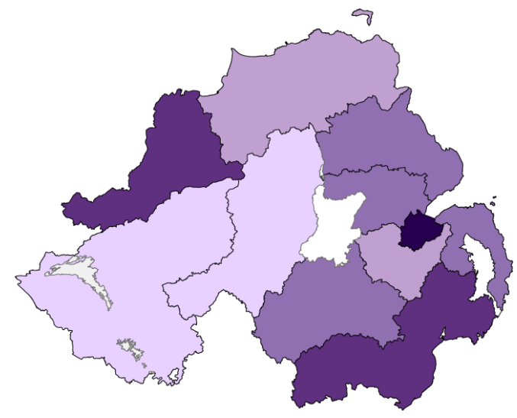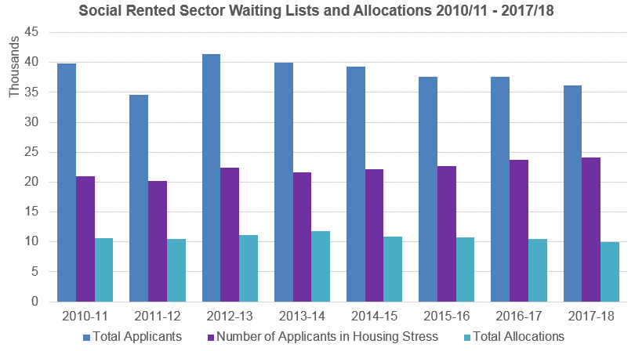

52

**Section Three – Social Renting Demand**

This section provides information relating to the social rented sector (Northern Ireland Housing Executive & Housing Associations). Detailed data and methodology notes on average weekly rents, housing benefit receipt, social housing waiting lists and allocations and homelessness can be found in the [accompanying tables](https://www.communities-ni.gov.uk/system/files/publications/communities/ni-housing-stats-17-18-tables3.XLS) and the [section 3 appendix](https://www.communities-ni.gov.uk/system/files/publications/communities/ni-housing-stats-17-18-appendix3.DOCX8).

**Social Rented Sector Waiting Lists**

**by LGD 2017-18**

* The Housing Executive holds data on all housing applications and allocations made through the Housing Selection Scheme* in the Housing Management System.
* The total number of applicants on the waiting list (with no existing NIHE/Housing Association tenancy) at 20th March 2018 was 36,198.
* Of these applicants, 24,148 were in ‘housing stress’ where they have 30 or more points under the Housing Selection Scheme.
* The Local Government Districts with the highest number of applicants were Belfast (10,136) and Derry City and Strabane (4,447).
* The number of properties allocated by the NIHE and Housing Associations to applicants on the waiting list who were not already social sector tenants was 7,373. This equates to 74% of total allocations made in 2017/18.
* In comparison the number of properties allocated by the NIHE and Housing Associations to tenants who had applied for a transfer from an existing tenancy was 2,625. This equated to 26% of total allocations made in 2017/18.

**Map based on Northern Ireland Housing Executive (NIHE) data. Map developed by ASU DfC. © Crown Copyright and database rights MOU209**

**Waiting Lists, Housing Stress & Allocations**

**2017-18**

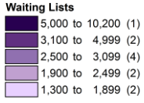

* More information on the Housing Selection Scheme can be found [here](https://www.communities-ni.gov.uk/housing-selection-scheme).

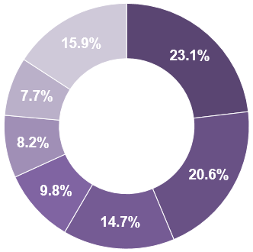

62

**Section Three – Social Renting Demand**

**Homelessness 2017-18**

**18,180**

Households Presenting as Homeless

**Top Reasons for presenting as homeless**



**Who is presenting as Homeless?**



Single Males (33%) and families (32%) were the biggest presenters of homelessness in 2017/18

Within the single males category, those aged between 26 and 59 were the highest presenters of homelessness with 4,350 cases

* Full Duty Applicant (FDA) status is granted to a household presenting as homeless once the NIHE makes enquiries to check if the household is eligible for assistance.
* The NIHE will need to satisfy itself whether the household has a priority need for accommodation and whether they became homeless or threatened with homelessness intentionally.
* Once a household is granted FDA status the NIHE has an obligation to ensure that accommodation becomes available for these households to occupy.
* The Housing Management system, introduced in July 2011, allows a greater number of outcomes to be reported in relation to homeless applications than before.
* In 2017-18, of the 18,180 households presenting as homeless, 11,877 households (65%) were accepted as full duty applicants and 4,688 (26%) were rejected. Of those households accepted as full duty applicants during the year 1,837 were discharged (Refer to Appendix 3 for definitions of each outcome).

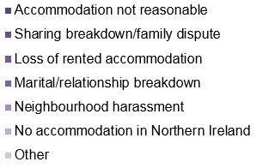

**Full Duty Applicants 2017-18**

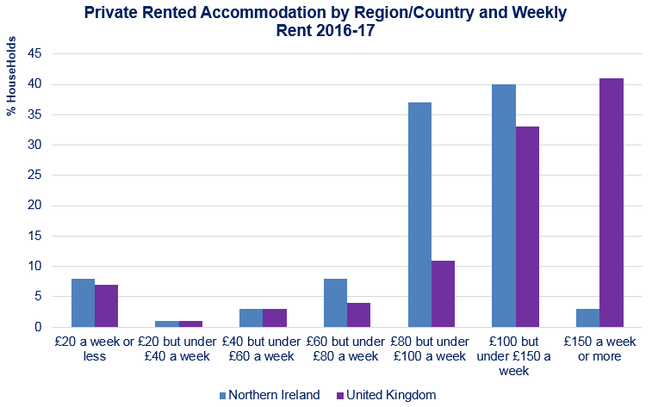

72

**Section Four – Private Renting Demand**

This section provides information relating to private renting demand. Detailed data and methodology notes on average rent and length of time of residence for private renters can be found in the [accompanying tables](https://www.communities-ni.gov.uk/system/files/publications/communities/ni-housing-stats-17-18-tables4.XLSX) and the [section 4 appendix.](https://www.communities-ni.gov.uk/system/files/publications/communities/ni-housing-stats-17-18-appendix4.DOCX)

.

* Estimates in this section are taken from the Family Resources Survey (FRS). The survey has been carried out in Great Britain since 1992, but 2002-03 saw its introduction to Northern Ireland for the first time. This section includes information from the 2016-17 versions of both reports.

**Average Weekly Rent**

* The estimated average (median) rent per week for the private rented sector in Northern Ireland in 2016-17 was £98, £40 below the UK average (£138) and lower than England (£148), Scotland (£115) and Wales (£109).
* The estimated average (median) rent per week for the social rented sector in Northern Ireland in 2016-17 was £77, £15 lower than the UK average (£92) and £21 lower than that of the private rented sector (figures may not sum due to rounding).

**Time in Residence**

* In 2016-17across the UK, 26% of private renters had resided in their accommodation for less than 12 months: similar to 25% in Northern Ireland. The proportion residing at their current address for five years or more was 25% across the UK compared to 32% in Northern Ireland.

**Key Points**

**Estimated Median Weekly Rent 2016-17**

**£77**

**NI**

**£98**

**NI**

Social Rented Sector

Private Rented Sector

**UK**

**UK**

**£92**

**£138**

This section provides information relating to owner occupied housing. Detailed data and methodology notes on the Northern Ireland House Price Index, National House Building Council (NHBC) new house sales and prices, the Northern Ireland Co–Ownership Housing Scheme, mortgages and mortgage possessions can be found in the [accompanying tables](https://www.communities-ni.gov.uk/system/files/publications/communities/ni-housing-stats-17-18-tables5.XLSX) and the [section 5 appendix](https://www.communities-ni.gov.uk/system/files/publications/communities/ni-housing-stats-17-18-appendix5.DOCX).



**121.7**

Standardised Price:

£135,060



**2.3%**

**Increase since last quarter**

**House Price Index – Quarter 3 July - September 2018**

82

**Section Five – Owner Occupier Demand**



**4.8%**

**Increase since Q3 2017**

Apartment **121.1 £105,826**

Semi-Detached **119.1 £130,100**

Detached **120.2 £201,921**

Terrace **126.9 £95,748**

* The NI House Price Index has been designed and produced by Land and Property Services to provide a measure of change in the price of a standardised residential property sold in Northern Ireland.
* The index uses information on all verified residential property sales as recorded by Her Majesty’s Revenue & Customs (HMRC).
* Note that the reference base period is Quarter 1 2015 and the index is set to 100 for that period. Results for the most recent quarter are provisional and subject to revision.
* The NI HPI currently stands at 121.7 in the third quarter of 2018.
* The overall index showed an increase of 2.3% since the previous quarter in 2018, and it has increased 4.8% since the same quarter in 2017.
* Verified residential property sales are defined as sales recorded by HM Revenue & Customs (HMRC) which could be matched to a domestic property in the NI Valuation List.
* In Quarter 3 2018 there were 5,722 verified residential property sales. This was less than Q3 2017 with a decrease of 12.4%.
* The number of loans granted to first-time buyers has generally risen year on year, from 2,900 in 2008 to 9,600 in 2017.
* The median percentage advance for first-time buyers was 80% in both 2008 and 2013, with a small amount of fluctuation in the intervening years. The general trend since 2013 has been an increase, to 86% in 2016, however, in 2017 the median percentage advance for first-time buyers was 85%.
* The median capital and interest payments as a percentage of income for first time buyers was 25.5% in 2008. Since then, the percentage for first-time buyers has fallen year on year; to 15.4% in 2017.

**30**

**Median Age:**

**Median Income:**

**£32,372**



**£**

**First Time Buyers: Lending and**

**Affordability**

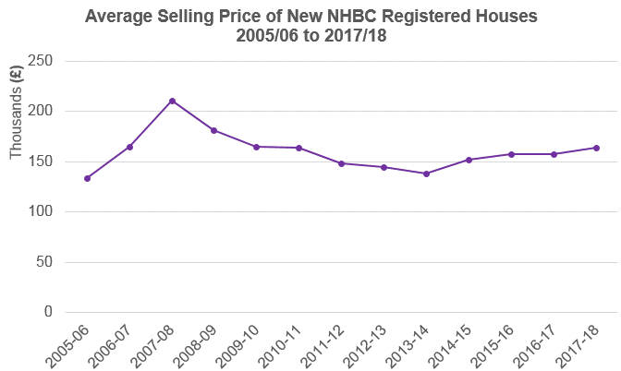

92

**Section Five – Owner Occupier Demand**

**NHBC New Dwelling Sales and Prices 2017-18**

* Data for new house sales and prices are derived from information provided by solicitors to the National House Building Council (NHBC). NHBC's primary purpose is to help raise standards to protect homeowners. NHBC is an independent non-profit distributing company, reinvesting all resources in further research and work to improve the construction standard of new UK houses for the benefit of homeowners.
* The average price of NHBC-registered new houses peaked in 2007-08 at £210,700. The average annual price stands at £163,900 for 2017-18. The average price has increased by 3.9% since 2016-17 (£157,700). Note that the monetary amounts for individual years have not been adjusted to account for inflation.
* With the exception of 2009-10 the number of NHBC new house sales fell year on year from 7,005 sales in 2004-05 to 1,142 sales in 2013-14. From there onward, sales have slowly risen, with the exception of 2016-17. The number of sales recorded for 2017-18 was 1,416, an increase of 16.4% from the previous year (1,216).

This section provides information relating to a range of household characteristics. Detailed data and methodology notes on household projections, household type, tenure and household income and expenditure can be found in the [accompanying tables](https://www.communities-ni.gov.uk/system/files/publications/communities/ni-housing-stats-17-18-tables6.XLSX) and the [section 6 appendix](https://www.communities-ni.gov.uk/system/files/publications/communities/ni-housing-stats-17-18-appendix6.DOCX).

**£497.10**

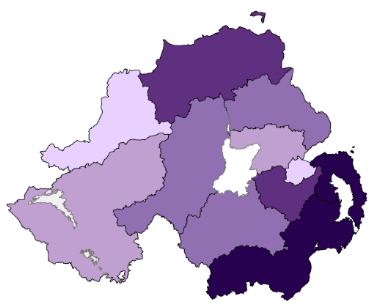

**Household Income by Tenure**

**2016-17**

**(Family Resources Survey)**



**Estimated Weekly Household**

**Expenditure NI & UK 2015-17\***

**(Living Costs & Food Survey)**

**Average Rates Bills 2017-18**

* Households with the highest housing costs were in the private rented sector, at £94 per week. This compares to estimates of £76 in the social rented sector and £47 for those buying with a mortgage.
* Those buying with a mortgage had the highest estimated average weekly household income of £914, followed by those who owned outright (£699) and private renters (£592). The social rented sector had the lowest estimated average weekly income of £386.
* For those buying with a mortgage, the majority of their estimated average income was generated from wages and salaries at 82%. In comparison, for social renters, social security benefits (48%) made up the largest proportion of income, with 26% generated through wages and salaries.



**£**

Average Weekly Household Income

**£691**

**NI Average Spend**

**£536.80**

**UK Average Spend**

* Rates are a property tax based on the valuation of homes in Northern Ireland. The income from rates provides funding for services at both local (Council) and regional (NI Assembly) levels.
* In 2017-18 the average rates bill was £938.
* The highest average bill payable was in Ards and North Down (£1,081) and the lowest was in Derry City and Strabane (£856).

**Map based on DoF data and developed by Analytical Services Unit, DfC. © Crown Copyright and database rights MOU209**

10

**Section Six – Household Characteristics**

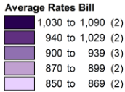

* For a full list of what ‘Average Spend’ encompasses, refer to Table 6.9 and Appendix- Section Six.

This report can be found on:

**www.communities-ni.gov.uk**

ISBN 978-1-904105-98-5

ISSN 0144 4433