**Northern Ireland Homelessness Bulletin**



October–March 2019

This publication has been developed by the Department for Communities (DfC), Northern Ireland Statistics and Research Agency (NISRA) and the Northern Ireland Housing Executive (NIHE). This bulletin presents a biannual summary of homelessness statistics in Northern Ireland. In this document you will find quick and concise coverage of the most up-to-date statistics available. More in depth statistics and information on methodology can be found in the accompanying tables and documents. These can be accessed [here.](https://www.communities-ni.gov.uk/publications/northern-ireland-homelessness-bulletin-october-march-2019)

**Key Points**



**Experimental statistics**

**Release date: 10 September 2019**



**Homeless presenters**

**Homeless acceptances**

**Temporary accommodation**

**67%**

(5,732)

Of those who presented were accepted as statutorily homeless

**8,527**

Homeless presenters

1. Accommodation not reasonable
2. Sharing breakdown/family dispute
3. Loss of rented accommodation

**Top 3 reasons for presenting**

**2,166**

Households living in temporary accommodation1

**Top 3 types of temporary accommodation**

1. Private single lets
2. Voluntary sector hostels
3. NIHE hostels

1. This figure refers to households placed in temporary accommodation by the Northern Ireland Housing Executive as of 3 July 2019.

**Contact**

If you have any queries or comments relating to this issue of the Homelessness Bulletin, please contact ASU via:

**Telephone:** (028) 90515418

**E-mail:** [asu@communities-ni.gov.uk](mailto:asu@communities-ni.gov.uk)

**Housing Team: James Sampson, Carley Bailie, Katie Fulton**

Alternatively, you can contact the Northern Ireland Housing Executive Homelessness Strategy team directly via:

**Maureen Kerr**

**Email:** Maureen.Kerr@NIHE.gov.uk

The Northern Ireland Homelessness Bulletin October–March 2019 is the second edition in a new series of experimental statistics that has been prepared by Analytical Services Unit of the Department for Communities (DfC). This biannual compendium of statistics contains information on a range of areas relating to homelessness. The report is currently divided into three sections which are: Homeless presenters; Homeless acceptances; and Temporary accommodation. More sections and/or tables may be added in future editions of this publication. All tables are sourced to the Northern Ireland Housing Executive (NIHE) administrative data on homelessness.

Homelessness figures presented in this report can be read in conjunction with those published in the quarterly Northern Ireland Housing Bulletin: <https://www.communities-ni.gov.uk/topics/housing-statistics>.

Experimental statistics are new Official statistics undergoing evaluation. They are published to involve users and stakeholders in their development and as a means to ensure they will meet user needs going forward. As these statistics are in an experimental stage, they are subject to retrospective revision in any future releases. The methodology and quality assurance of this data is still under development and subject to change.

Feedback on the bulletin is particularly welcome from users. This will be used to further develop the publication and accompanying tables in line with user requirements. If you would like to participate in our user engagement survey, please do so by following this link: <https://consultations.nidirect.gov.uk/dfc-analytical-services-unit/homelessness-user-engagement-survey>

**Please note that this is a summary document and that detailed data and information on methodology and data quality, can be found annexed at:** https://www.communities-ni.gov.uk/topics/housing-statistics

**If you think you are homeless and require further advice or support, please contact the Northern Ireland Housing Executive via:**

**Telephone:** 03448 920 900 **Website:** <https://www.nihe.gov.uk/Housing-Help/Apply-for-a-home>

**1**

**Contents**

**Section One: Presenters**

**Section Two: Acceptances**

**Section Three: Temporary accommodation**

**Glossary**

**About this publication**

**Introduction**

**What is meant by ‘homelessness’?**



Becoming homeless can happen to anyone. A person may be homeless if they are:

* staying with friends or family
* staying in a hostel
* staying in a bed and breakfast
* living in very overcrowded conditions
* at risk of violence if they stay in their home
* living in poor conditions that are damaging their health
* living in a house that is unsuitable for them
* rough sleeping

Homelessness is often understood as people living on the streets. However, whilst rough sleepers may represent one element of homelessness, it is a misconception to think that these are the only homeless people who need help. Even those who have a roof over their heads may still be included in the homeless definition.

The Northern Ireland Housing (NI) Order 1988 (as amended) tasks the Northern Ireland Housing Executive with responding to homelessness, and places a statutory duty on the Housing Executive to provide interim and/or permanent accommodation for certain homeless households, dependent upon investigations and assessment of their circumstances.

This report seeks to provide a more thorough understanding of homelessness through statistics, case studies, and factual information.

**What about rough sleepers?**

Whilst there are no statistics on rough sleepers in this publication at present, the Housing Executive perform annual street counts of rough sleepers in Belfast, Londonderry and any other area where street activity is identified by the Homelessness Local Area Groups. Additional data from the PSNI and others is also analysed following standard practice for establishing the number of rough sleepers across the UK.

The latest results were collected in November 2018 and can be found here:

<https://www.nihe.gov.uk/getmedia/665fcdd6-146e-4389-8a3b-c3d5c8403f23/Tackling-rough-sleeping-in-NI-key-facts-figures.pdf.aspx>



**2**

**Introduction**

David is a 19 year old male who lived at the family home and had been unable to secure employment since leaving school. David’s parents became increasingly concerned that he was taking drugs and had noticed money missing from the family home. Frequent arguments between David and his parents began to impact negatively on his younger brothers and, reluctantly, David’s parents felt they had no choice but to ask him to leave.

David presented as homeless to the Housing Executive. The Housing Advisor contacted David’s parents to confirm that they had asked him to leave. David’s mother confirmed that this was the case, and stated that she felt she had no choice given her lack of knowledge in how to help David.

The Housing Advisor highlighted a support agency she could refer David to that helped young people with substance abuse and supported them in finding employment. David was happy to engage with this service as he didn’t want his life, and his relationship with his parents, to continue deteriorating. David’s mother agreed to have him back home, on condition that he take up the referral to the support service. David continues to work with floating support services, abstains from drugs and has applied for an apprenticeship.

*This section contains a wide range of information on those who have submitted an application to the Northern Ireland Housing Executive. Detailed data on: households presenting by reason; by household type; by Local Government District (LGD); by decision; and households rejected by legislative test outcome can be found in the* [*accompanying tables*](https://www.communities-ni.gov.uk/publications/northern-ireland-homelessness-bulletin-october-march-2019)*.*

**3**

**Section One: Homeless presenters**

* Population statistics taken from the most recent NINIS mid-year estimates. These can be accessed [here.](https://www.ninis2.nisra.gov.uk/public/PivotGrid.aspx?ds=8972&lh=73&yn=1991-2017&sk=74&sn=Population&yearfilter=)

** Scenarios are based on information taken from NIHE homelessness presentation data, but are not based on the circumstances of any one individual.

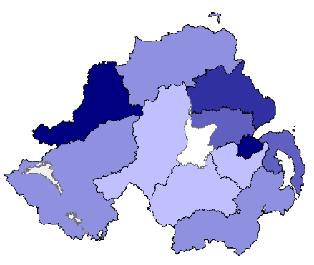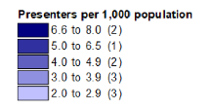

**Homeless presenters by Local Government District October–March 2019\***

**Scenario 1: Sharing breakdown/family dispute homeless presentation (outcome: prevented)\*\***

A homeless ‘presenter’ is a household that is undergoing a homelessness assessment by the Housing Executive. This assessment consists of four legislative tests (The Northern Ireland Housing Order 1988 (as amended)) which determine whether or not a duty is owed to the household. These include tests for: eligibility; homelessness; priority need and; intentionality (see glossary at the back of this document for definitions). Even households who currently have somewhere to live that may be unsuitable can apply to be considered legally homeless.

In October–March 2019, 8,527 households presented as homeless in Northern Ireland. The map above shows how many households presented as homeless per 1,000 population in each Local Government District (LGD). The LGD with the largest number of presenters per 1,000 population was Belfast with 7.5. This was followed by Derry City and Strabane (6.7) and Mid & East Antrim (5.0).

8,527Homeless presenters

**Top reasons for presenting as homeless**

**Section One: Homeless presenters**

**4**

**Accommodation not reasonable breakdown**

When a household presents as homeless, an initial reason for presenting is allocated by a housing advisor from the Housing Executive based on the information provided in the application. During the subsequent investigation of the application a more appropriate reason may be determined. As a result, the household could potentially be accepted as statutorily homeless with a different reason than that which they initially presented with.

Of the 8,527 households who presented as homeless in October–March 2019, the most commonly quoted cause was ‘accommodation not reasonable’ with 2,156 (25%), followed by sharing breakdown/family dispute with 1,832 (21%), and loss of rented accommodation with 1,270 (15%).

The category ‘accommodation not reasonable’ (ANR) does not have a single definition. It is an umbrella category in which there are 7 sub-categories. These are: financial hardship; mental health; overcrowding; physical health/disability; property unfitness; violence; and other. Of the accommodation not reasonable cases, ‘physical health/disability’ had the largest proportion of presenters with 65%.

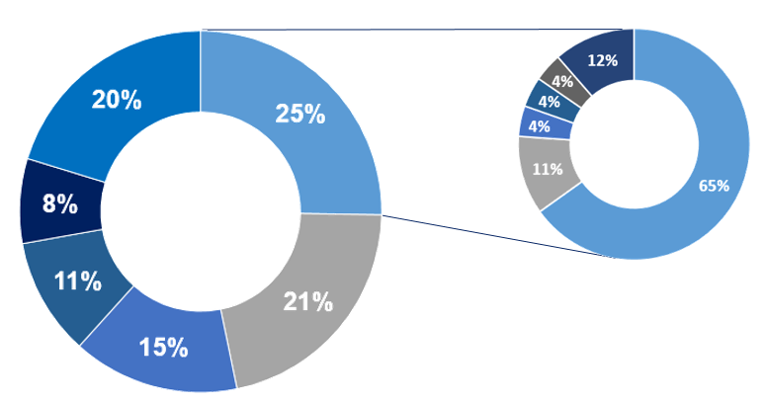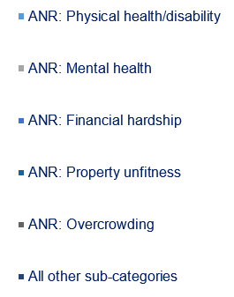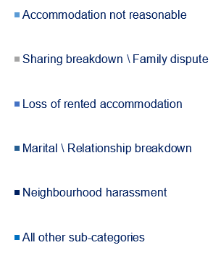

**Homeless presenters by decision**

When a household presents as homeless to the Housing Executive, four legislative tests are carried out to assess whether or not a duty is owed to the household.

The chart below shows the various outcomes of those who were assessed between October–March 2019.

Definitions for each of these outcomes can be found in the glossary at the back of this document.

Of those who presented, 60% were accepted as homeless, 8% were duty discharged within the same period, and 21% were rejected.

**What does ‘duty discharged’ mean?**

To become ‘duty discharged’ an applicant who has been awarded full duty status must either: be rehoused; refuse three reasonable offers of



housing; or re-house themselves/no longer require help from the Housing Executive.

**5**

**Section One: Homeless presenters**

Whilst the chart (left) shows 647 cases being duty discharged, this is only referring to those who presented as homeless, were accepted, and subsequently duty discharged, all within this 6 month time period.

It should be noted that other households, accepted as full duty applicants outside of October-March 2019, will also have been duty discharged during the period. For information, the overall number of cases duty discharged between April 2018 and March 2019 was: 8,481.

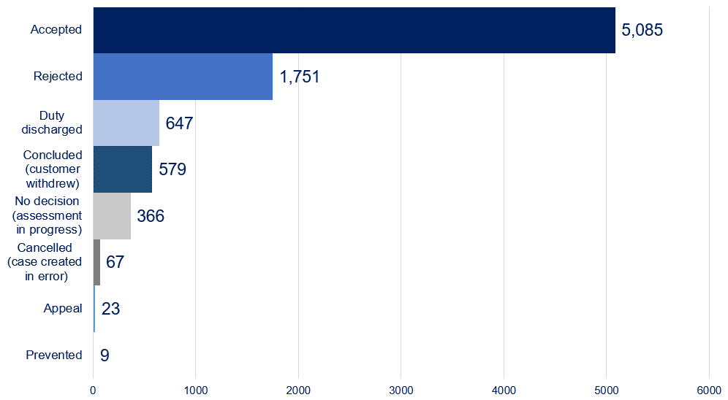

**What happens to those who are rejected?**



A rejected case is where a household has failed to meet one or more of the statutory tests for homelessness. For these clients certain duties around providing advice and assistance still remain. The Homeless Persons’ Advice and Assistance Regulations (NI) 2011 (the Regulations) requires the Housing Executive to provide homeless people with the following:

* Housing advice;
* Advice on social issues;
* Financial advice;
* Advice on legal procedures and services.

The advice and assistance referred to in the regulations must be provided to any homeless applicant whether they are “eligible persons” or not. This advice is a duty that is owed to anyone who might seek advice and assistance regardless of eligibility or homeless status. The aim of this duty is to prevent homelessness.

**How is homelessness being prevented?**

'Homelessness prevention' means providing people with help and support to address their housing and other needs, to avoid homelessness. Homelessness prevention can best be achieved by intervention at the earliest possible stage.

[The Homelessness Strategy for Northern Ireland 2017-22](https://www.nihe.gov.uk/Housing-Help/Homelessness/Homelessness-strategy) notes that “for many people, becoming homeless is not the beginning of their problems; it comes at the end of a long line of crises”. This means that by the time a household presents to the Housing Executive as homeless, many opportunities may have been missed to prevent the homelessness occurring. In recognition of this, the Housing Executive and the Department for Communities fund and/or support a range of organisations that provide advice and assistance to households approaching crisis before homelessness occurs. These include:

* Housing Rights Service
* Community Housing Advice Partnership (CHAP)
* Housing Advice Prisons Service
* Housing Advice NI
* Beyond the Gate Service

It is difficult to provide accurate figures for homelessness prevention given the methods used to record it and the fact that responsibility is shared across several different DfC and NIHE funded organisations. The ‘prevented’ category in the “Homeless presenters by decision” chart found on the previous page does not fully reflect all the work being done to ensure that as many potential homeless cases are prevented as possible. Later editions of this publication will aim to provide better quantification of prevented cases, when data is made available.



**6**

**Section One: Homeless presenters**

**3,180**

Vulnerable

**1,584**

Dependent children

**737**

Violence

**176**

**206**

Pregnant

**Statutorily homeless by priority need test outcome**

In Quarter one of 2017/18 xx,xxx households presented as homeless

*This section contains a wide range of information on those who have been accepted as ‘statutorily homeless’ by the Housing Executive. Detailed data on: acceptances by reason; by household type; by Local Government District (LGD); by priority need; by outcome; and children in households accepted as homeless, can be found in the* [*accompanying tables.*](https://www.communities-ni.gov.uk/publications/northern-ireland-homelessness-bulletin-october-march-2019)

**Who was accepted as statutorily homeless?**

In Quarter one of 2017/18 xx,xxx households presented as homeless

Of the 8,527 homeless presenters between October-March 2019, 67% (5,732) were granted Full Duty Applicant status and accepted as statutorily homeless, and 11% of these (647) were discharged within the same time frame. This means that the applicant has either (a) been rehoused, (b) rejected three reasonable offers, or (c) has rehoused themselves/no longer needs assistance. (See page 5 for more information)

The top three reasons for being accepted as homeless were: accommodation not reasonable (1,846, 32%), sharing breakdown/family dispute (1,056, 18%) and; loss of rented accommodation (743, 13%).

The ‘priority need test’ shows that for some reason, the household would struggle to cope as homeless more than others.

The most frequent outcome of the priority need test of those accepted was to be categorised as ‘vulnerable’ with 56% (3,180). Households can be classed as ‘vulnerable’ for a multitude of reasons including, but not exclusively: old age; illness; mental health problems; or physical disabilities.

Other outcomes include those classified by the test as: having “dependent children” (1,584, 28%); experiencing “violence” (737, 13%); “pregnant” (206, 4%); or classed as emergency (25, <1%)*.

**What is a ‘Full Duty Applicant’?**



In order to be “accepted” as statutorily homeless a household must meet the four tests of: eligibility; homelessness; priority need; and intentionality.

Any household that meets these four tests will be accepted as a “Full Duty Applicant” (FDA) and will be owed a full housing duty. The full housing duty includes ensuring that accommodation is made available for the household as well as the provision of temporary accommodation where necessary and assistance with the protection of the household’s belongings.

***For more definitions, see the glossary at the back of this document.***

**7**

**Section Two: Homeless acceptances**

* May not sum due to rounding

Emergency **(25)**

**Households accepted as homeless, by household type**

**Section Two: Homeless acceptances**

**Children from homeless households**

The households accepted as statutorily homeless between October–March 2019 included a total of 3,698 children. Please note, however, this does not mean that there were 3,698 households with children, as one household can have multiple children.

As can be seen from the chart below, the largest proportion of these children were aged 0–2 (24%), followed by 3-5 (19%), 6-8 (17%), 9-11 (16%), 12-14 (13%), and finally 15-17 (11%).

**Children from households accepted as statutorily homeless, by age**

Of the 5,732 households who were accepted as statutorily homeless, slightly more than a third were families (2,069). This was followed by single males (1,385), single females (1,030), pensioner households (1,008) and couples (240).

Of all single males and females who were accepted as statutorily homeless, those who fell into the 26-59 age group made up the largest proportion (1,101 and 616 respectively).

It is important to monitor the prevalence of household type in regards to homelessness to both inform housing need, and the development of the housing strategy.

**8**

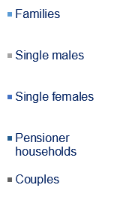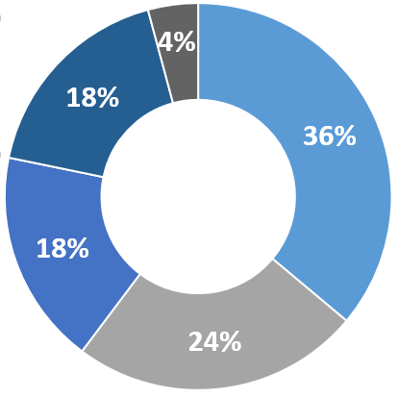

**5,732**

**Households  accepted as homeless**

*

* Families do not necessarily include children under the age of 18. Families may, for example, include parents and children who are over the age of 18 or adult siblings/other relatives living together.

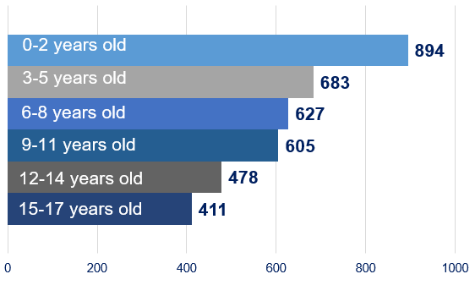

**Section Three: Temporary accommodation**

*This section contains a wide range of information on placements in temporary accommodation. Detailed data on: placements in temporary accommodation by household type and by accommodation type; children in temporary accommodation; and current placements by banded length of stay, can be found in the* [*accompanying tables*](https://www.communities-ni.gov.uk/publications/northern-ireland-homelessness-bulletin-october-march-2019)*.*

**Scenario 2: Multiple placements in temporary accommodation\***

Michael and Claire had lived in the same property in the private rented sector for 5 years with their two children aged 11 and 9.  Unfortunately Claire was unexpectedly made redundant. The sudden drop in income meant that they could no longer afford their rent and the couple began to fall into arrears. Despite seeking debt advice and reducing their outgoings, it was clear that their current property was too expensive and inevitably the landlord issued them with a notice to quit.

The family presented to the Housing Executive as homeless and were awarded full duty applicant status as they were unintentionally homeless and in priority need as they had dependent children. As they had no accommodation and were unable to stay with friends or family, the Housing Advisor secured a place at a family hostel for them.  The family hostel consisted of independent units for each family to occupy but also had communal areas with computers and other resources for the families to use. The hostel provided support to families to help them to become “tenancy ready”.

While Michael and Claire were grateful for the placement, it was agreed that as they had managed a tenancy successfully for many years, they did not require the level of support provided by the hostel. After a few weeks the Housing Advisor was able to secure a single let for the family. This freed up the place at the hostel for another family with higher support needs, and allowed Michael, Claire and their children to live independently in temporary accommodation in the private sector until a more permanent offer of housing could be made.

**What is ‘temporary accommodation’?**

The Housing Executive has two main accommodation duties: the interim duty to accommodate; and the full housing duty. The first dictates that if a client is homeless and has a priority need, they can be accommodated pending the full investigation of their circumstances. The latter applies to clients who meet the four statutory homelessness tests (as described in previous chapters).

Temporary accommodation can be utilised to address both of these duties. That is, a client could be placed here during their investigation or after becoming a full duty applicant whilst waiting for a permanent offer of rehousing.

The types of temporary accommodation used by the Housing Executive are:

* Private single lets
* Voluntary sector hostels
* NIHE hostels
* Hotel/B’n’B
* Dispersed Intensively Managed Emergency Accommodation (DIME)

*For definitions of each of these types of accommodation, please see the glossary at the back of this document.*

Whilst not all clients require placement in temporary accommodation (they may prefer to stay with friend or family or make their own arrangements), for those who do Housing Executive staff will endeavour to place them in the most appropriate accommodation for their needs. Within the portfolio there will be places available for clients with high, medium, low and no support needs. For example, there are hostels that can deal with clients dealing with addiction who may not be immediately ready to take up and sustain a tenancy. In these circumstances, staff will seek a placement in an appropriate hostel that will have on-site support workers who will support the client to become “tenancy ready”. This will improve their chances of maintaining a long term tenancy when one is offered. Many clients find the support provided from their assigned temporary accommodation invaluable.



**9**

*Scenarios are based on information taken from NIHE homelessness presentation data, but are not based on the circumstances of any one individual.

* Chart refers to households in temporary accommodation at the given point in time as opposed to placements.

** Chart presents the overall number of **placements** to temporary accommodation. These are not distinct households as one household can have several placements in a short timeframe.

**Section Three: Temporary Accommodation**

**10**

**Section Three: Temporary accommodation**

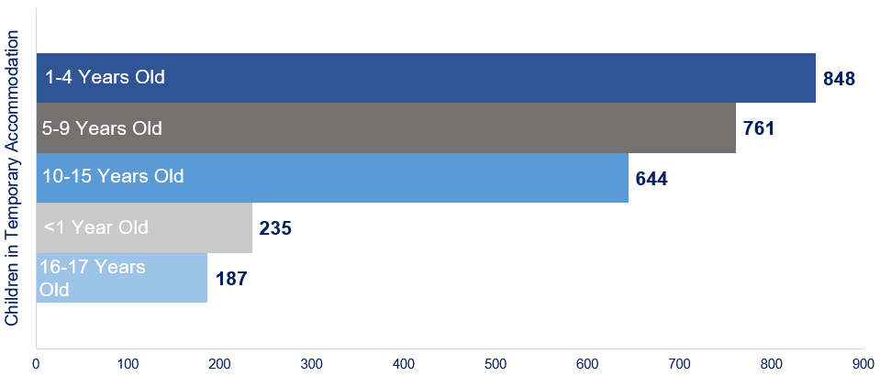

**Children in temporary accommodation, by age (as of 3 July 2019)**

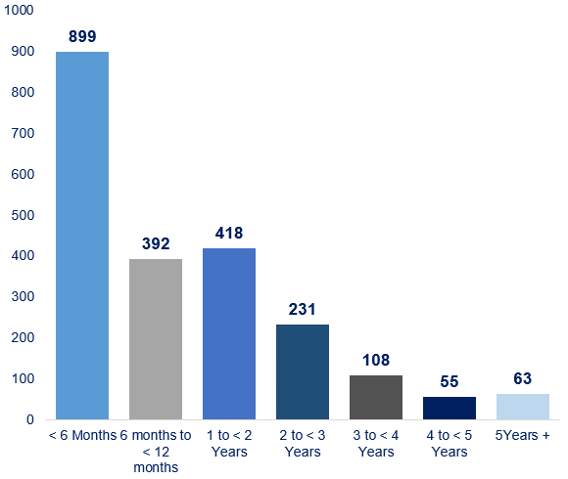

At 3 July 2019 there were 2,166 households in temporary accommodation, the majority of which (60%) had been living there for less than 12 months. Conversely, 3% of these had been living in temporary accommodation for 5 or more years.

Within these 2,166 households, there were 2,675 children living in temporary accommodation.

Between October-March 2019, there were 1,726 **placements** to temporary accommodation. Of these, 37% were to private single lets (642), 27% were to hotels or B’n’Bs (459), and 21% were to voluntary sector hostels (362).

**Placements in temporary accommodation by accommodation type\*\***

1. Private single lets
2. Voluntary sector hostels
3. NIHE hostels

**Top 3 types of accommodation**

**Households in temporary accommodation by banded length of stay (as of 3 July 2019)\***

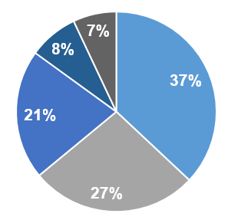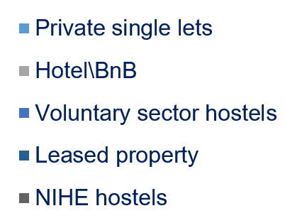

**Glossary**

**Accepted (as a decision)**

Applicant has been accepted as statutorily homeless and awarded Full Duty Applicant status

**Appeal (as a decision)**

Applicant has sought a review of their homelessness decision

**Cancelled (as a decision)**

A homelessness application was registered in error by the Housing Executive

**Concluded (as a decision)**

Applicant has withdrawn their homelessness application, or has not made contact with the Housing Executive within a specified period

**Dispersed Intensively Managed Emergency Accommodation (DIME)**

**(as temporary accommodation)**

This accommodation is for clients with extremely high support needs

**Duty discharged (as a decision)**

Applicant has been awarded full duty status and subsequently (a) the applicant has been re-housed in the social or private sector, (b) the applicant has been presented with three reasonable offers of accommodation which are all refused, or (c) the applicant re-houses him/herself and is no longer interested

**Full Duty Applicant (FDA)**

In order to be “accepted” as statutorily homeless a household must meet the four tests of: eligibility; homelessness; priority need; and intentionality.

Any household that meets these four tests will be accepted as a “Full Duty Applicant” (FDA) and will be owed a full housing duty. The full housing duty includes ensuring that accommodation is made available for the household as well as the provision of temporary accommodation where necessary and assistance with the protection of the household’s belongings

**Homeless presenter**

A homelessness ‘presenter’ is a household that has applied to undergo a homelessness assessment by the Housing Executive.

**Hotel/B’n’B (as temporary accommodation)**

Hotel or B’n’B accommodation is only used in exceptional circumstances and for as short a duration as possible.

**NIHE hostels (as temporary accommodation)**

NIHE hostels are self-contained units of accommodation suitable for households with low support needs or for households with higher support needs with the addition of floating support.

**Legislative test (homelessness tests)**

When a household applies to become statutory homeless, they will undergo four legislative tests as per Northern Ireland the Housing (NI) Order 1998 (as amended). They are as follows:

1. **Eligibility test –** this test will assess if you are ineligible due to not having the right to reside in the UK or due to unacceptable behaviour;
2. **Homelessness test –** this test will investigate whether or not you can reasonably continue to live in your home;
3. **Priority need test –** this test will investigate if there is a reason that the presenter would struggle to cope as a homeless person more than others.
4. **Intentionality test –** this test will look to see if the applicant intentionally did something, or failed to do something that resulted in their homelessness.

**11**

**Glossary**

**No decision (as a decision)**

Homelessness application is still being processed.

**Prevented (as a decision)**

Homelessness has been prevented by an action or intervention by the Housing Executive, another agency, or the applicant themselves.

**Private single lets (as temporary accommodation)**

A single let is a private dwelling which is made available on a temporary basis to a homeless household while they are waiting for permanent rehousing. These dwellings are normally in the private rented sector.

**Rejected (as a decision)**

Applicant does not meet the statutory homelessness criteria.

**Voluntary sector hostels (as temporary accommodation)**

Voluntary sector hostels are funded by Supporting People. They are mainly self-contained units of accommodation such as grouped houses/flats. Voluntary sector hostels provide accommodation based support for vulnerable households. Some will also have communal areas where households can come together to take part in activities, socialise or avail of facilities such as computers or communal cooking/eating areas. The support provided in these hostels is designed to assist vulnerable households to become tenancy ready to enable them to sustain a permanent tenancy when they are allocated one. Some clients may opt to defer permanent allocations until they feel they have the necessary skills to maintain their tenancy. Crash beds are available for overnight accommodation for emergency placements (eg, rough sleepers).

**12**