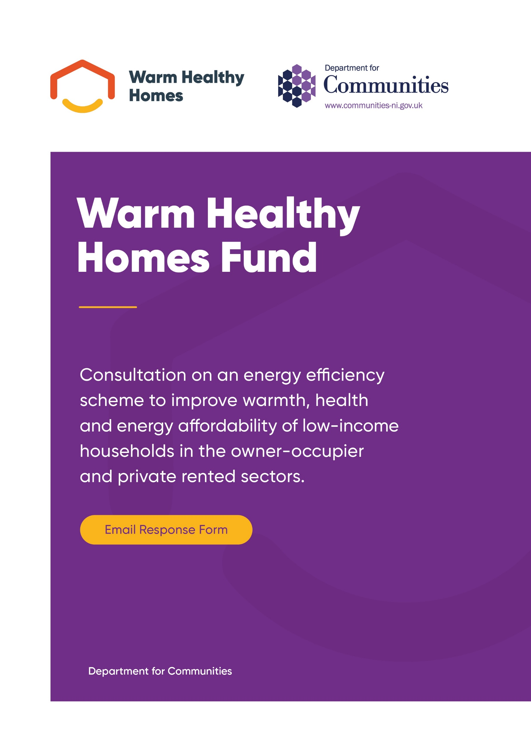

Warm Healthy Homes Fund Consultation
Enquiries to:
Home Energy Branch
Department for Communities
Causeway Exchange
1-7 Bedford Street
Belfast
Antrim
BT2 7EG
Email: HEB@communities-ni.gov.uk
Web: www.communities-ni.gov.uk/consultations/consultation-warm-healthy-homes-fund

How to Respond
This consultation will be hosted online at the following website: NI Direct - Citizen Space. The Citizen Space website has been specially designed to be as user-friendly and welcoming as possible for those who wish to complete the consultation. It also allows DfC to rapidly collate results. For this reason, we would encourage anyone who is interested in responding to this consultation to utilise Citizen Space as the method of their response.
Your response will be most useful if it is framed in direct response to the questions asked, though further comments and evidence are also welcome.
If this is not possible, you can however respond to this consultation via email to HEB@communities-ni.gov.uk by completing this form on the departments website or you can respond in writing to the following address:
Warm Healthy Homes Fund Consultation
Department for Communities
Climate Change Division
4th Floor, Causeway Exchange
1-7 Bedford Street
Belfast
Antrim
BT2 7EG

When responding via email or in writing, please state whether you are responding as an individual, or representing the views of an organisation (please state the name of the organisation). Please also quote the following reference in your response: “Warm Healthy Homes Fund Consultation”. In addition, when replying via email, it is possible to add supporting information to your response, either by way of an attachment or by posting text in the body of the email. Please ensure that you reference the question the additional information is in response to when doing so.
Responses must be received by 23:59 on 19 August 2026.
Please contact us if you require this document in an alternative format for accessibility purposes.

General Information
Name:
Email Address:

What best describes your interest in this consultation
- Member of the public
- Academia
- Energy Efficiency/Heating supplier
- Energy Efficiency/Heating installer
- Government representative
- Arms Length Body
- Fuel Poverty representative organisation
- Other (please specify)

Please indicate if you are replying as:
- An individual / Member of the Public
- On behalf of a body or organisation (please specify who you represent below)

Proposal: Eligibility

Question 1

Given the limitations of funding, the Department proposes that households in receipt of the Personal Allowance of Universal Credit (for three consecutive periods) and those in receipt of Pension Credit are eligible for assistance. In addition, income under a set threshold will also be used as an eligibility criterion. It proposes that the total household income threshold of the new Warm Healthy Homes Fund should be set at the rate of the National Living Wage, which is currently £29,741.40, net of tax and national insurance, and that it should rise annually in line with the National Living Wage.

Under this proposal, the Department proposes to exclude certain disability and health related benefits and allowances from the income threshold, including the winter fuel payment, recognising that these households may have higher energy needs.
Do you agree with the proposed approach when assessing eligibility for the Warm Healthy Homes Fund?

☐ Yes
☐ No

Please give reasons for your answer limited to 500 words.

Proposal: Savings
The Department proposes that household savings should be taken into account in a proportionate way, recognising the need for some savings while ensuring support is targeted at those most in need.
Under this proposal, households may hold up to £6,000 in combined personal savings without this affecting eligibility. Savings above this level would be treated as income using an established approach already applied in other government schemes. The rate at which savings are counted would differ depending on the age of the applicant, with a more generous treatment for those aged 60 and over.
The Department is seeking views on whether this approach to savings is appropriate.
Question 2

Do you agree with the proposed approach to how household savings are treated when assessing eligibility for the Warm Healthy Homes Fund?

☐ Yes
☐ No

Please give reasons for your answer limited to 500 words.

Proposal: Prioritisation of applications
Given the large number of households likely to be eligible for the Warm Healthy Homes Fund and the limited budget available, the Department proposes prioritising applications after eligibility has been confirmed.
To ensure funding is targeted at those most in need, the Department proposes prioritising properties with the lowest energy efficiency. Applications would therefore be prioritised based on the Energy Performance Certificate (EPC) rating of the property, with priority given to homes rated EPC E or below, as these households are more likely to experience severe fuel poverty.
All eligible properties would require a home assessment to confirm the EPC rating. Home assessments would be carried out on a first-come, first-served basis; however, due to budget constraints, not all eligible properties may ultimately receive support.
The Department is seeking views on whether this is an appropriate approach to prioritisation.
Question 3

Do you agree that the Department should prioritise Warm Healthy Homes Fund applications based on the energy rating of the property?

☐ Yes
☐ No

Please give reasons for your answer limited to 500 words.

If you answered no, do you think that the Department should prioritise applications based on another reason?

Please provide detail limited to 500 words.

Proposal: Private Rented Sector

Question 4

The Department proposes that Private Rented Sector landlords may access fully funded cavity and loft insulation, draught proofing, and ventilation, provided their tenant meets Warm Healthy Homes Fund eligibility criteria.
Do you agree with this proposal?

☐ Yes
☐ No

Should additional measures be included such as replacement windows, solar photovoltaic (PV) systems and electrical energy (battery) storage?
Do you agree with this addition?

☐ Yes
☐ No

If you answered No to either of these questions, please give reasons for your answer limited to 500 words.

Proposal: Grant Limits

The Department proposes setting a grant limit of £35,000 for the Warm Healthy Homes Fund that will allow for a fabric first, whole house approach including Air Source Heat Pump, solar photovoltaic (PV) systems and electrical energy (battery) storage.
This will be increased to £45,000 to support those ‘hard-to-treat’ properties i.e. those of Non-Traditional Construction, Solid Wall Construction or have Environmental Constraints.
Up to £500 will be included within the grant limit for properties that require some general maintenance or remedial works before energy efficiency measures can be installed. It is anticipated that not all properties will require the full grant limit.

Question 5

Do you agree with this proposal?

☐ Yes
☐ No

If you answered No, please give reasons for your answer limited to 500 words.

Proposal: Application Limit

Question 6

The Department proposes that an applicant may apply only once to the Warm Healthy Homes Fund and that the Home Assessment will determine what support that property would benefit from.

Do you agree with this proposal?

☐ Yes
☐ No

If you answered No, please give reasons for your answer limited to 500 words.

Proposal: Quality Standards
To ensure that energy efficiency measures delivered through the Warm Healthy Homes Fund are installed safely, consistently and to a high standard, the Department proposes that registered contractors working on the scheme should be assigned to householders and that they must hold appropriate, measure-specific accreditations.
Question 7
The Department proposes that a list of registered contractors would be provided to households to deliver the works identified by the Home Assessment, ensuring ease of access and a streamlined service for applicants.
Do you agree with this proposal?
☐ Yes
☐ No

If you answered No, please give reasons for your answer limited to 500 words.

To work on the Warm Healthy Homes Fund, a contractor must be VAT-registered, be registered with the Managing Agent to work on the Warm Healthy Homes Fund, and be accredited to a relevant trade body, including:
- Gas Safe (must be gas safe registered to install gas appliances)
- NICEIC (Electrical work)
- British Board of Agrément (BBA) (Loft, cavity wall, solid wall)
- Solid Wall Insulation Guarantee Agency (SWIGA) (Solid wall)
- National Insulation Association (NIA) (Loft, cavity wall)
- Cavity Insulation Guarantee Agency (CIGA) (cavity wall).
- Microgeneration Certification Scheme (MCS) (small-scale renewable energy systems)
- Installation Assurance Authority – (single compliance platform)
The proposed approach reflects current practice across government-funded energy efficiency schemes and is intended to provide assurance on quality, consumer protection and technical competence. As the Fund develops, it is proposed that contractor standards would align with those used in other government schemes, which may include a transition to PAS 2030 and PAS 2035 standards or similar.

Question 8
Do you think that industry is ready to adopt or move to the principles of PAS 2030/ 2035?
☐ Yes
☐ No

If you answered No, please give reasons for your answer limited to 500 words.

Question 9
Are there any other alternative standards or accreditations that may be applied to contractors working on all government energy efficiency schemes?
☐ Yes
☐ No
Please provide detail limited to 500 words.

Proposal: Aftercare
It is proposed that initial aftercare advice will be available to all applicants. This will be a routine follow up between 6 and 12 weeks after installation to ensure that equipment is being used correctly and effectively. It is anticipated that the Managing Agent will instigate the aftercare by telephone to establish if a follow up visit is required. Should a visit be needed then the contractor who completed the works should visit the property to address any concerns or issues.
Question 10
Do you think that the proposed aftercare arrangements are sufficient?
☐ Yes
☐ No
If you answered no, please provide additional detail (limit of 500 words) on any additional aftercare that the Managing Agent of the Warm Healthy Homes Fund should provide.

Equality Considerations
Question 11
Please comment on any potential equality implications you feel may arise from the issues/proposals discussed in this consultation.

Privacy Notice

Data Controller Name: Department for Communities
Address: Causeway Exchange, 1-7 Bedford Street, Belfast, Antrim, BT2 7EG
Email: HEB@communities-ni.gov.uk

The Privacy Notice, which explains how and why your data is processed, can be viewed at Warm Healthy Homes Fund Consultation

